Git hub tasks- 02
1 install git
Yum install git
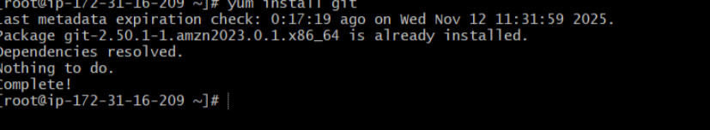
2 Create a repo in GitHub with README.md and. ignore file
The purpose of repository has been stored in readme.md
We can also input some content and also how to execute
To create a new .gitignore file we need to add new file and create it
Once you comeback you can see list of files In your repository
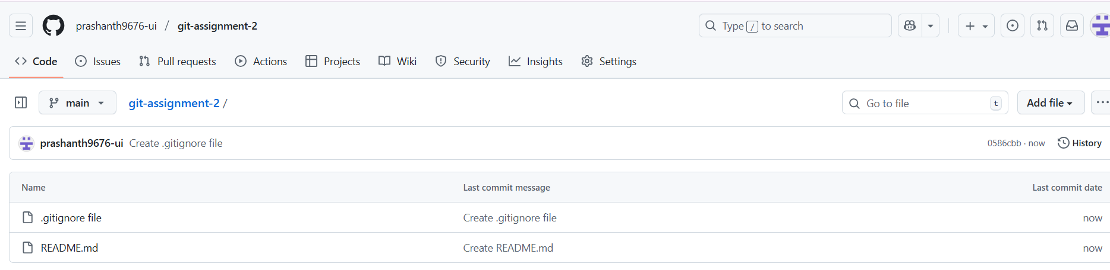
3 Clone the created repo to local.
First create a file in your repository
Now in gitbash use git clone and paste the url of your repository
ls
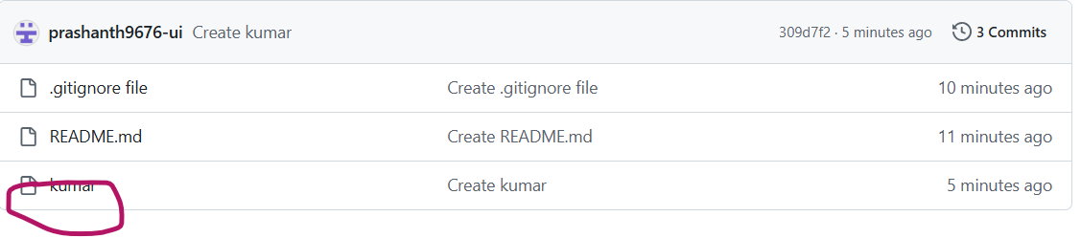
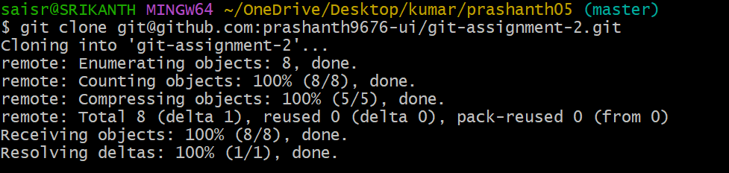
Now to view give ls and to view in that file give cd filename , you can see the files which have been created
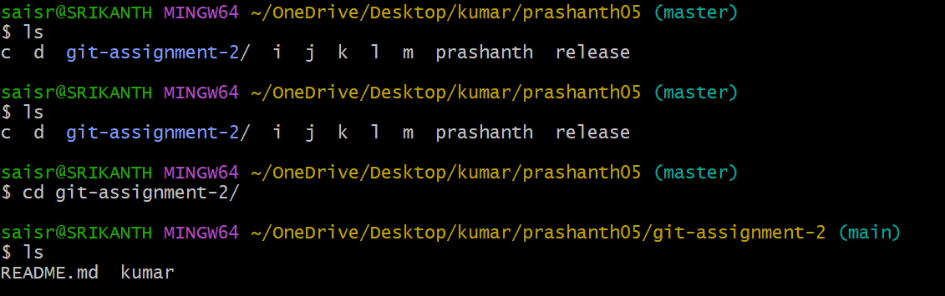
4 Create two files in local repo.
To create two files in local machine use touch
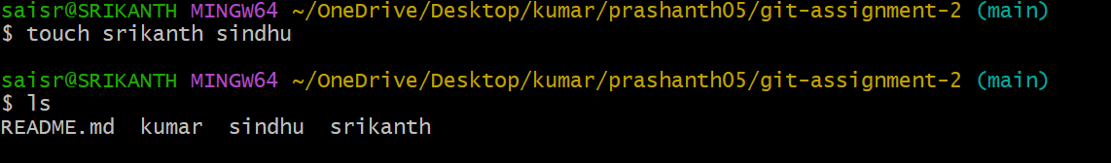
5 Commit two files and push to central Repository.
If u create two files first, if u give git status it will be in untracked. Now to move to tracvked we use git add .
Now u want to commit it by using git commit -m “message”
Once it ahs been committed to move to central repository
Use git push -u origin master
And once it ahs been done refresh the page in repository
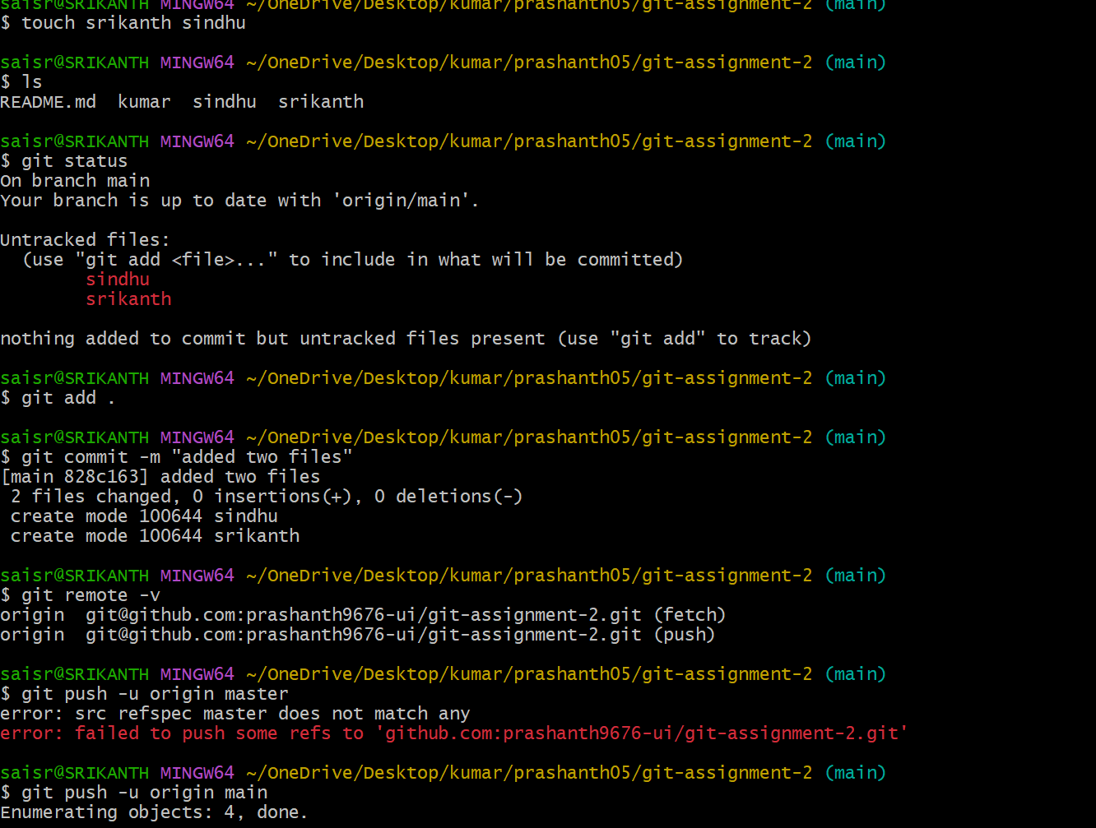
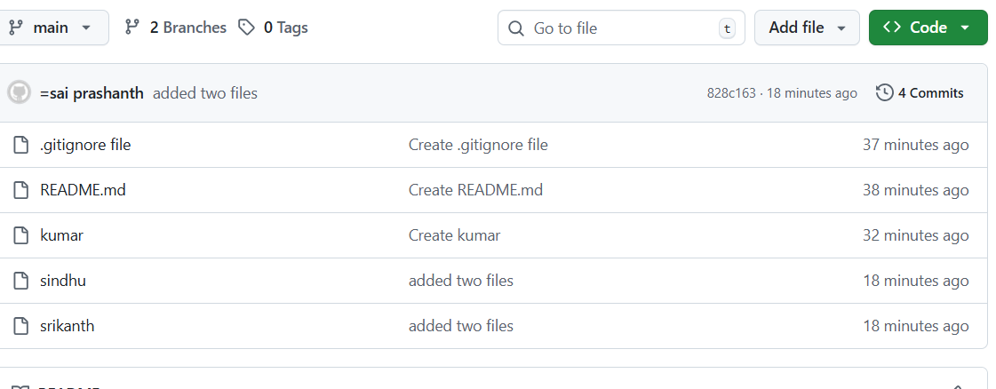
6 Create a branch in local and create a sample file and push to central.
First create a new branch with command git branch newbranchname
To view git branch –-list
To switch to new branch git checkout newbranchname
Now create a sample file e.g.: Instagram
Move from untracked to tracked and commit it and now move to repository by using
git push -u origin master
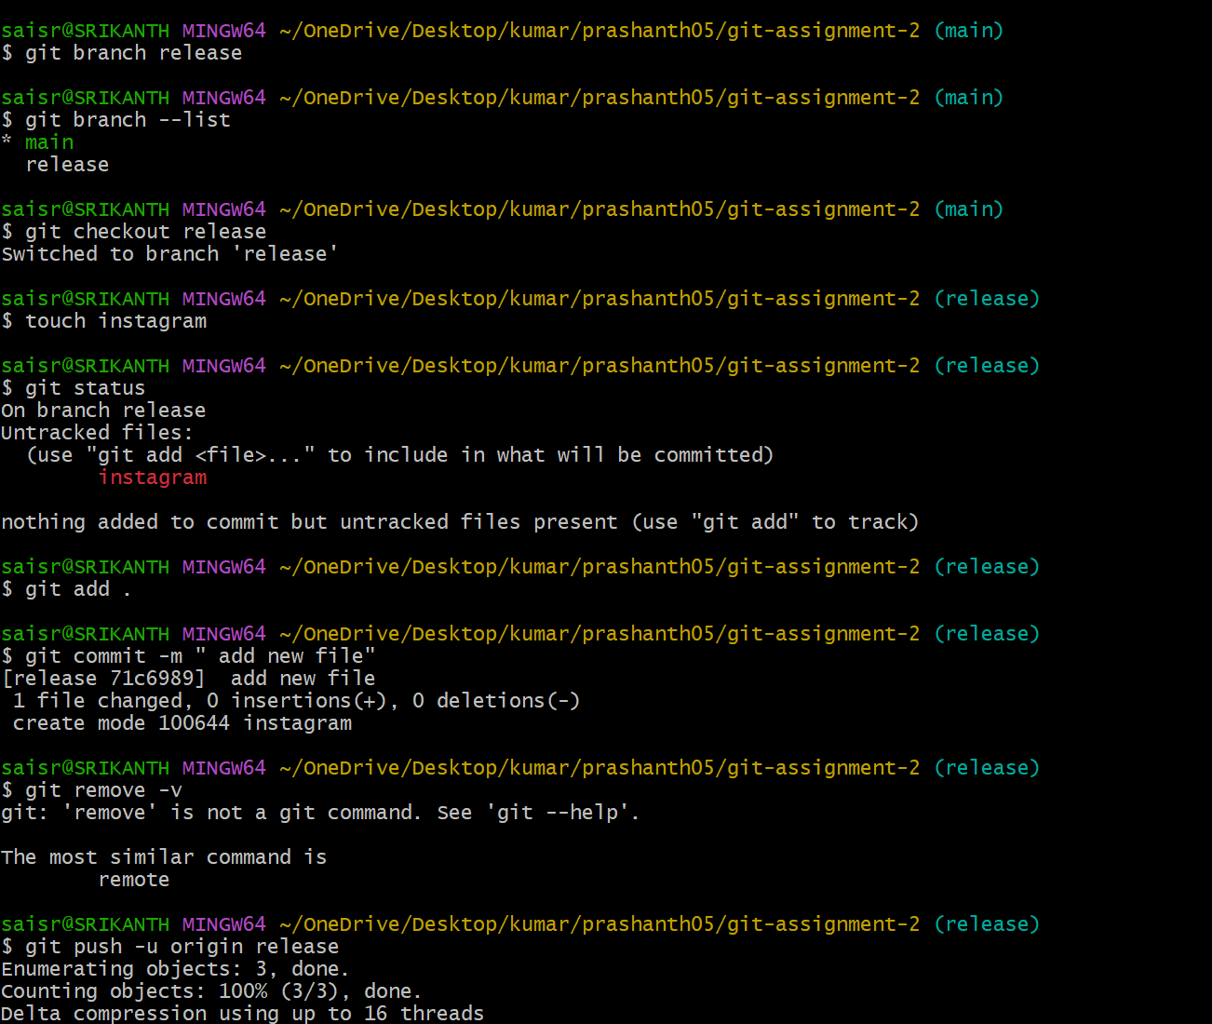
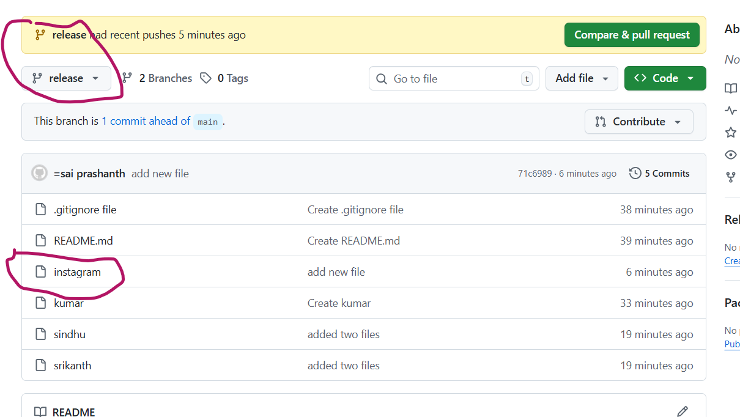

7 Create a branch in GitHub and clone that to local.
First create a branch in github
Now use git pull command to clone to local
Now switch to new branch and view the branch list
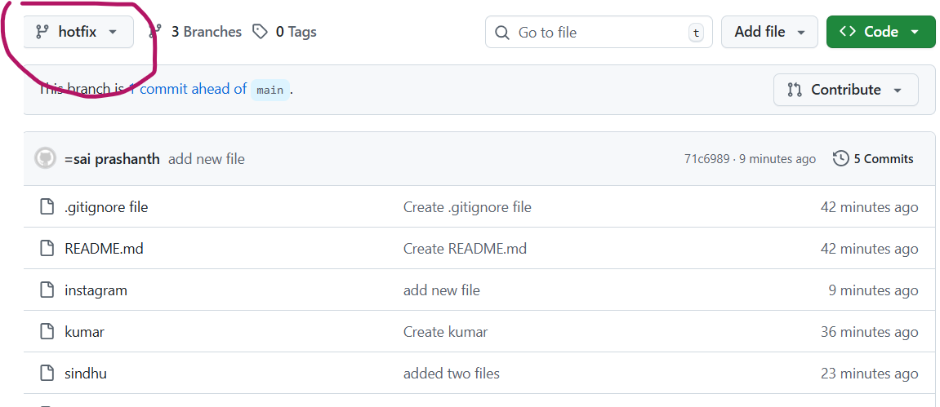
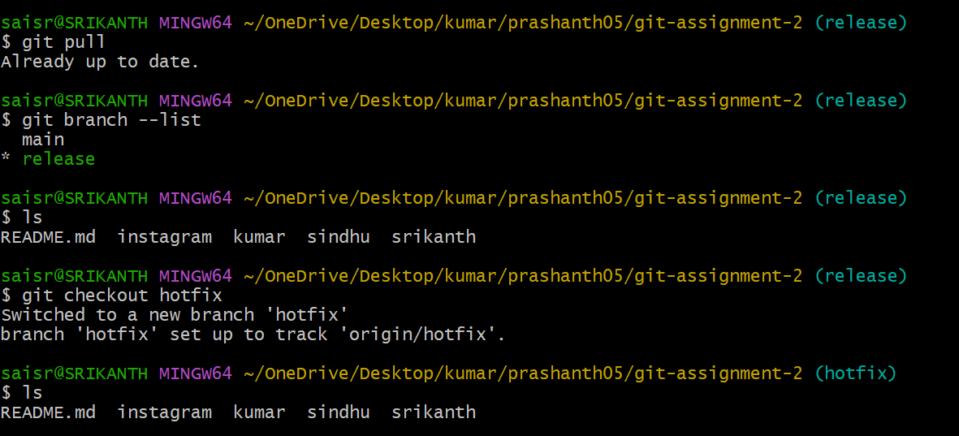
8 Merge the created branch with master in git local.
git merge branchname
e.g. git merge hotfix
now whatever u have created files in hotfix branch it will get to the main branch
example: you created Instagram in hotfix branch
now if you give ls command
you can see the file has been merged into main branch

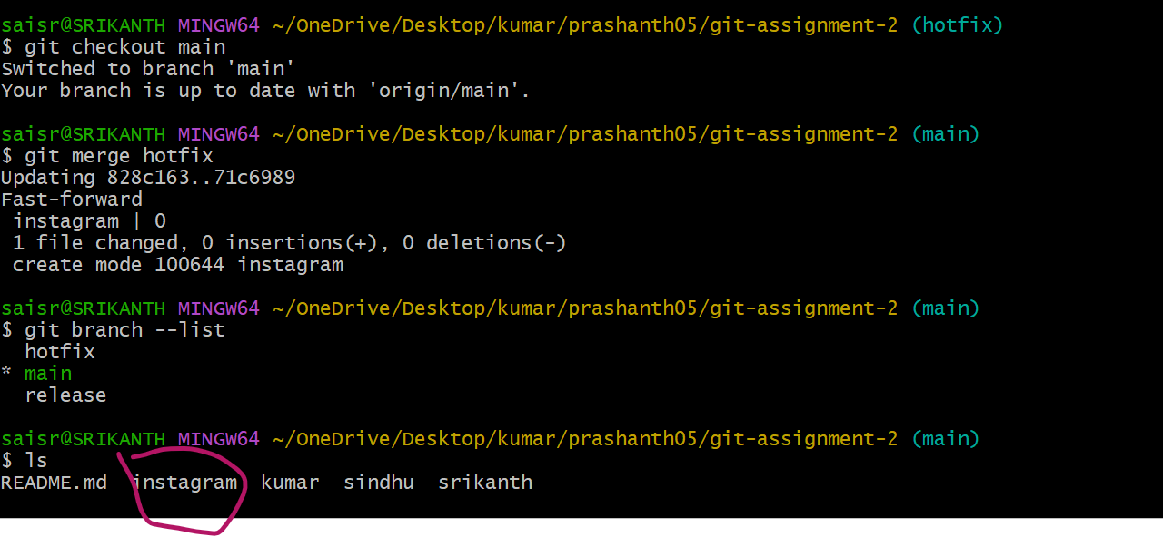
9 Merge the created branch with master in GitHub by sending a pull request.
To merge go to repository and create a file and click on pull compare pull request
For example, you want to merge from release to main branch
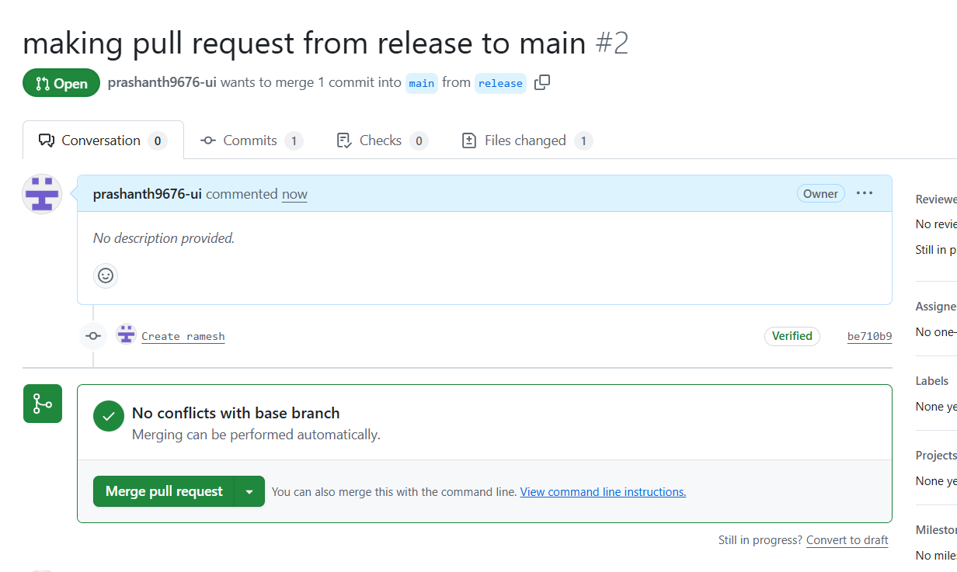


- Create a file in local and send that to branch in GitHub.
First to create a file use touch and create filename
Then do untracked to tracked and commit and now push to which branch u want to move the file by using command git push -u origin main
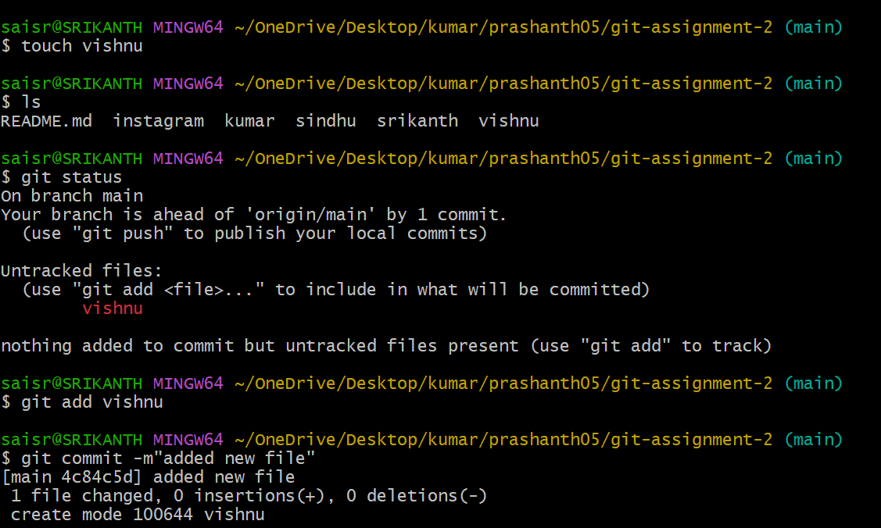
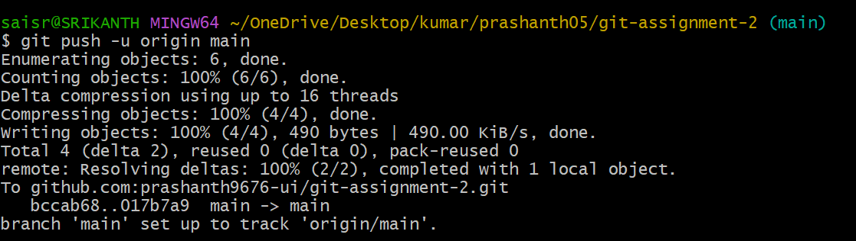
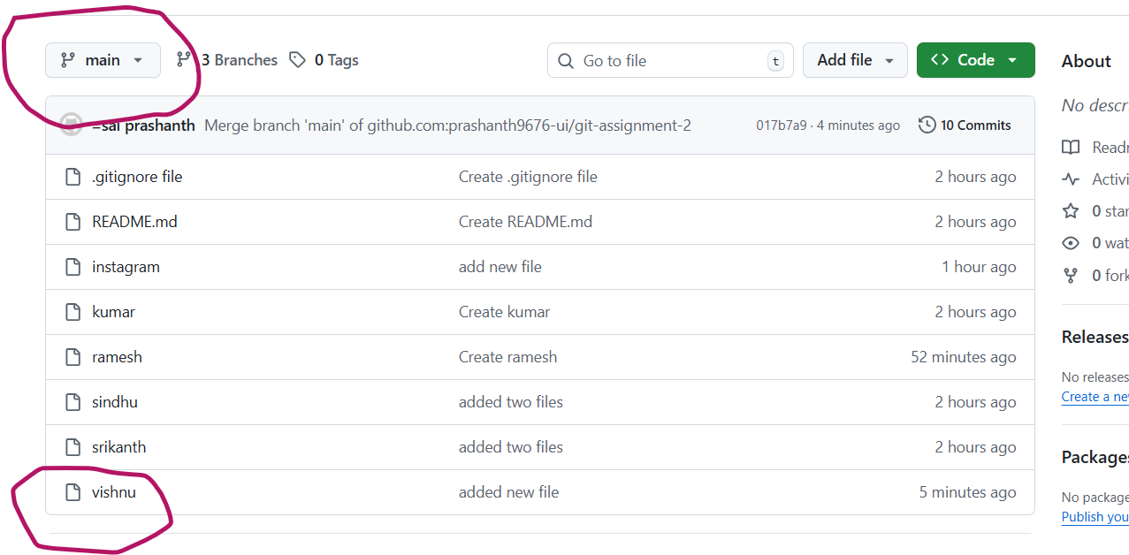
- Clone only a branch from GitHub to local.
To clone only a branch from central repository to local
We need to use git clone --branch release --single-branch git@github.com:prashanth9676-ui/git-assignment-2.git
Here example branch release I used
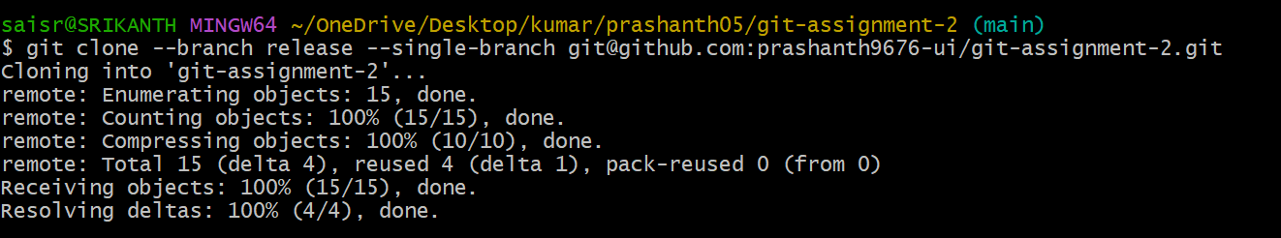
- Create a file with all passwords and make that untrickable with git
touch password
.i have created a password2 file in vi .gitignore
Now if u give ls -la you can see the file password2
Then if we execute git add . and git commit’
The file password2 has been discarded and file is untrickable
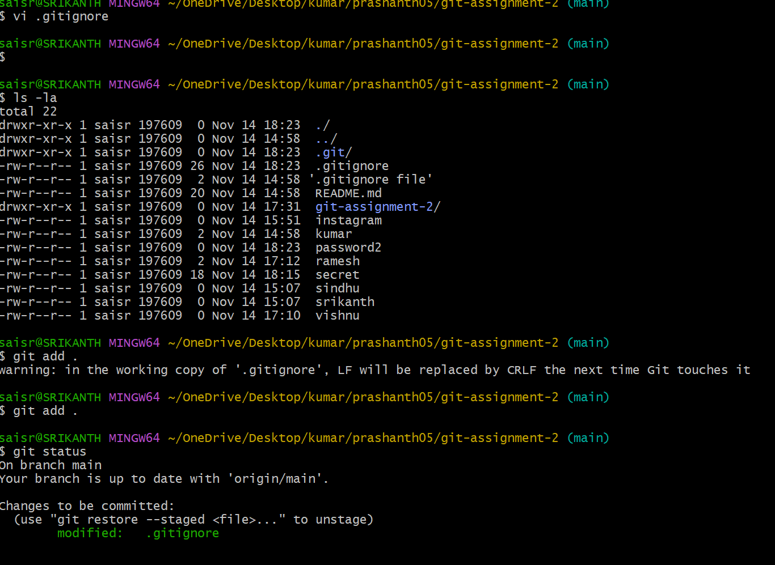

- Make a commit and make that commit reset without savings changes.
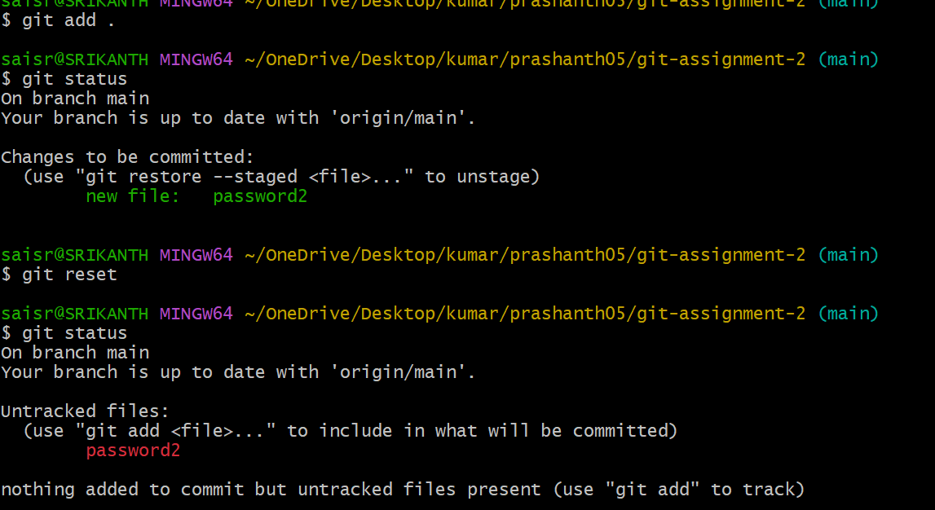
- Revert a committed commit to the older version.
To use revert first we need to use git log command
Then we need to revert it by using git revert with commit id
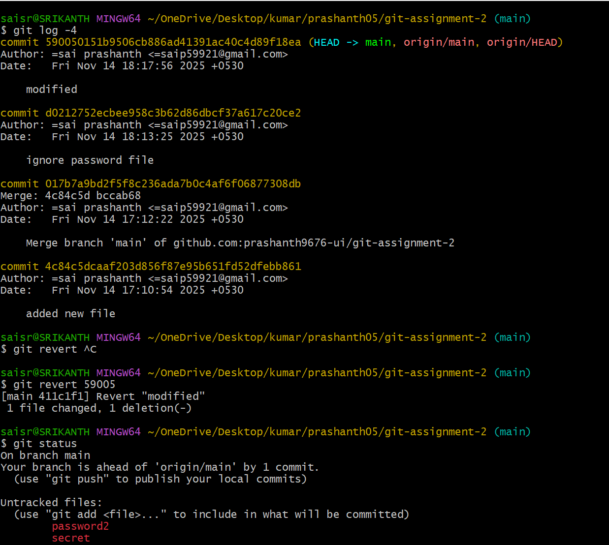
- Push a file to stash without savings the changes and work on another file.
If you created any file u can move it temporarily to the stash memory by using
git stash command
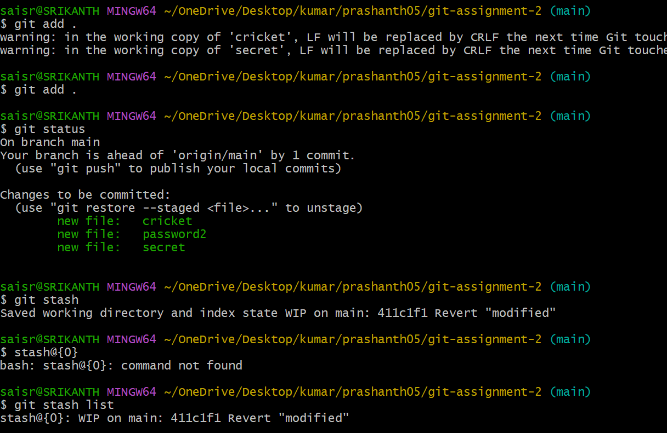
- Undo the stash file and start working on that again.
By using git stash pop command we can get back the files from stash memory
First to see the stash list we can use git stash list command
Now if you check again git stash list as we have executed the command it has been restored again
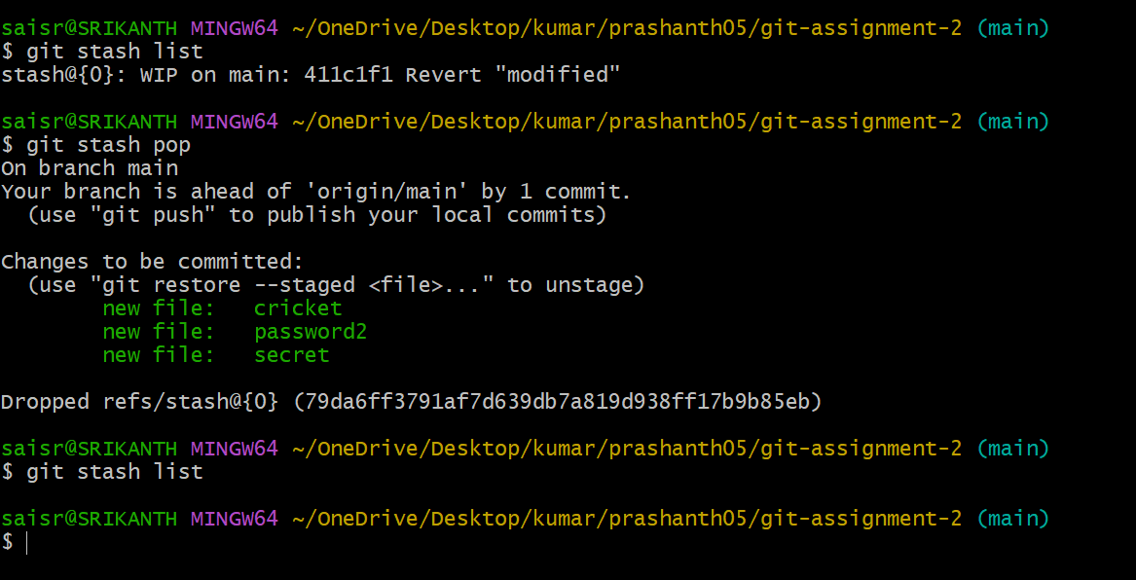

- Generate a ssh-keygen and configure into GitHub.
First, we need give ssh-keygen and enter
Then we need to copy in GitHub repository and got to settings keygens tab
Paste the link and click on ssh key add
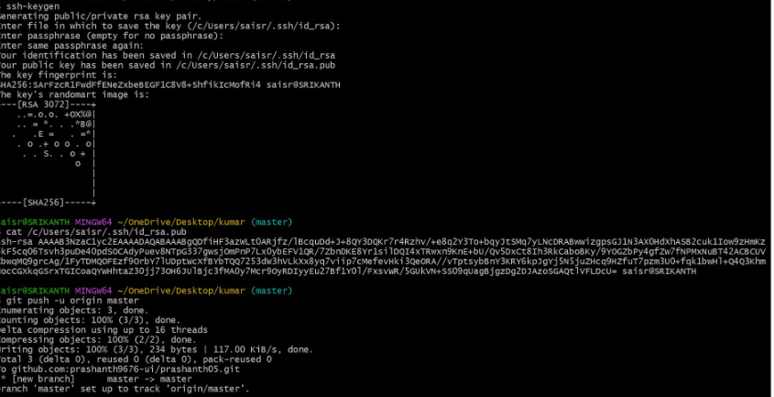
- Basic understanding of .git file.
When you first initiate and run we need to use git init
Then it creates hidden file called .git in your project
It means it is used completely to track your project
It is the main or heart of your project.
It stores commits,files,history,configuration,branches,logs etc…
- Check all the logs of git.
To check the logs, we need to use git logs
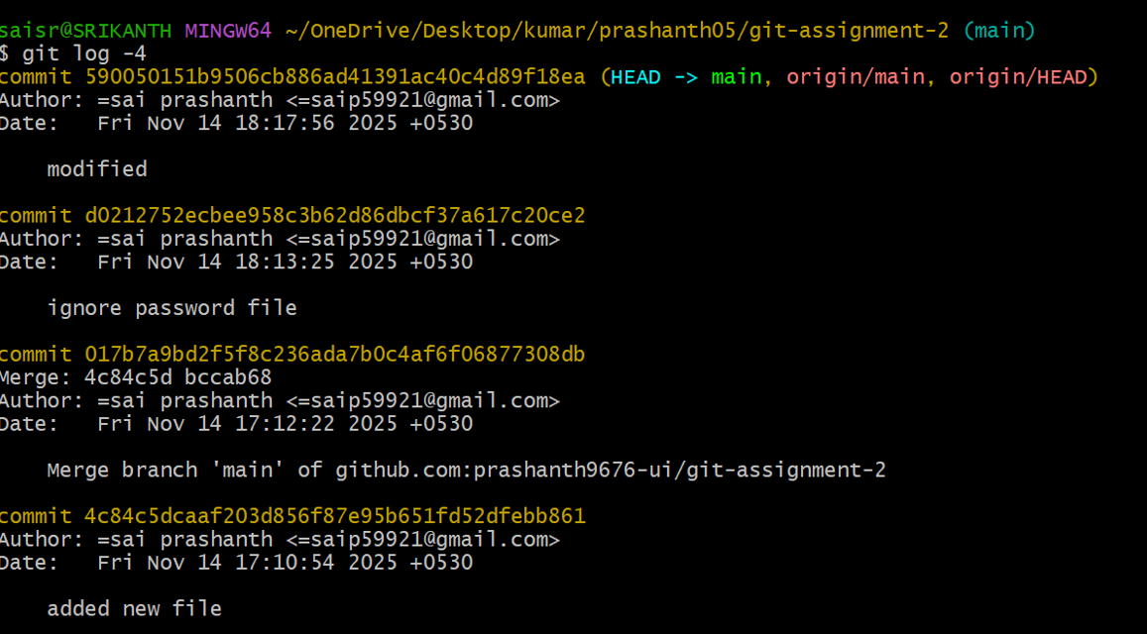
- Rename the commit message.
By using git commit –amend we can rename the commit message whatever you want to rename
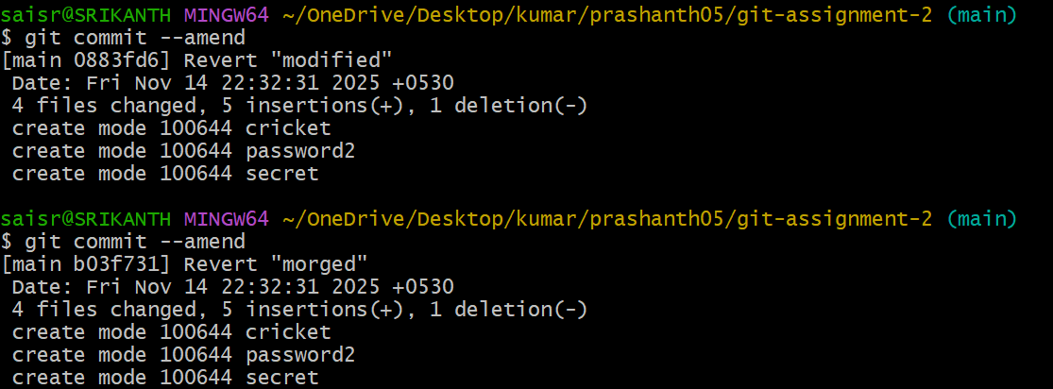
- Merge multiple commits into single commit.
First we need to git log
We can see lot of commits
Now to commit all into single commit
We need to use git rebase -I HEAD~how many files you want to merge
But do not use and try to modify the commits or merge into single commit
